**Dungeness River winter steelhead SONAR-based escapement estimates 2018-2022**

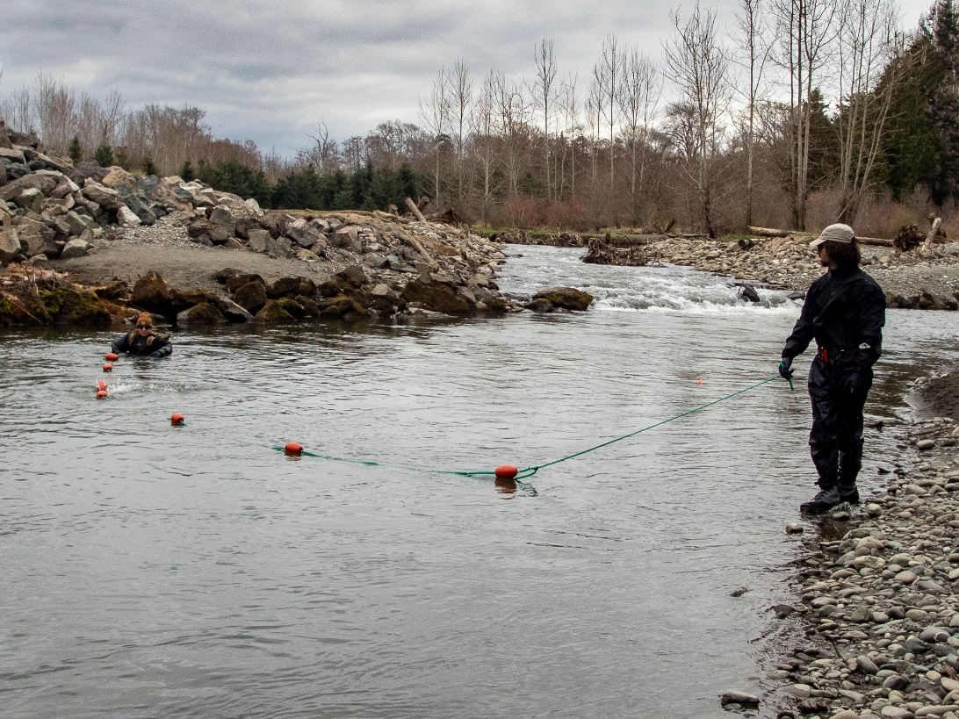

Bethany Craig, Kevin See, and Joseph Anderson

The Washington Department of Fish and Wildlife

Draft Report

May 30, 2023

# Introduction

Steelhead spawning ground surveys in the Dungeness River basin are inherently challenging due to springtime snow melt and rain events which can lead to high, turbid water and unsafe survey conditions. In most years it is not possible to survey for steelhead through the entirety of the spawning season, and in some years poor survey conditions prevent an adequate number of surveys from being completed to estimate escapement based on redd counts. SONAR may provide an alternative method for steelhead enumeration and run timing in a dynamic, turbid snow-melt system like the Dungeness watershed. Since 2018 the Washington Department of Fish and Wildlife (WDFW) has operated a stationary multi-beam SONAR unit in the lower Dungeness River to enumerate and gather run-timing information on winter steelhead (*Onchorhynchus mykiss*).

# Methods

## SONAR operation

In 2018 the SONAR unit was deployed at approximately at river mile (RM) 0.2, below the majority of steelhead spawning habitat, and ensonified an approximately 20 meter (m) wide run in the river (Figure 1). The SONAR unit was mounted to a pole mount and attached to a reinforced ladder, secured to the river bottom by rebar (Figure 2). Fish frequently milled or held in front of this SONAR site, which made counting fish passage difficult, and in 2019, the SONAR site was moved upstream to approximately RM 0.3, to a site with higher velocity, past which fish actively migrated (Figure 1). This site was easily accessible from the field trailer site, which enabled the unit to be directly connected and powered by trailer power, and any adjustments to the SONAR settings to be accomplished in the dry, safe comfort of the trailer.

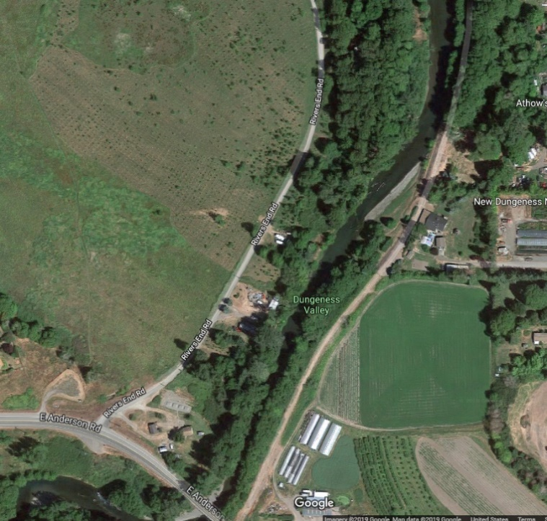

**Figure 1** Location of the SONAR site in the lower Dungeness River in 2018 (white) and 2019-2022 (striped) .

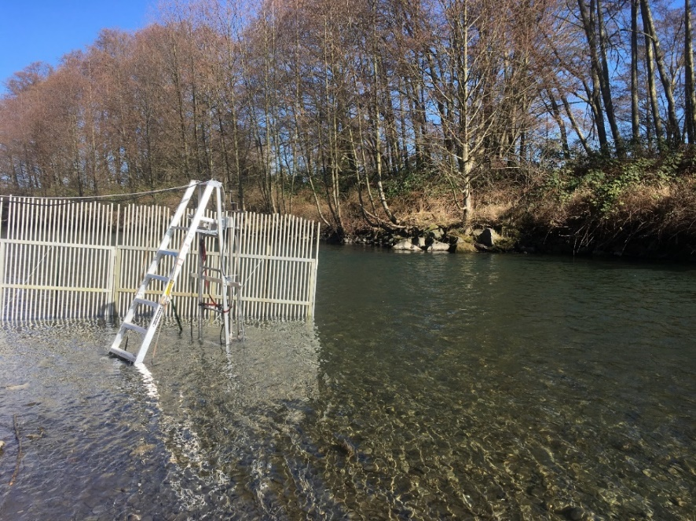

**Figure 2** SONAR unit deployment via a pole mount and ladder system in the Dungeness River in 2018.

Midway through the 2019 season the SONAR unit was mounted on a semi-permanent platform along the hardened left bank, in a spot that is protected and retains adequate depth so that the SONAR unit did not need to be shifted laterally to accommodate changing water levels (Figure 3).

In all years a picket weir was constructed approximately 1 m upstream of the SONAR unit from the bank, extending out to approximately 1 m past the SONAR, to deflect debris (Figure 3). A second picket weir was constructed approximately 1 m downstream of the SONAR unit to direct migrating fish out in front of the unit.

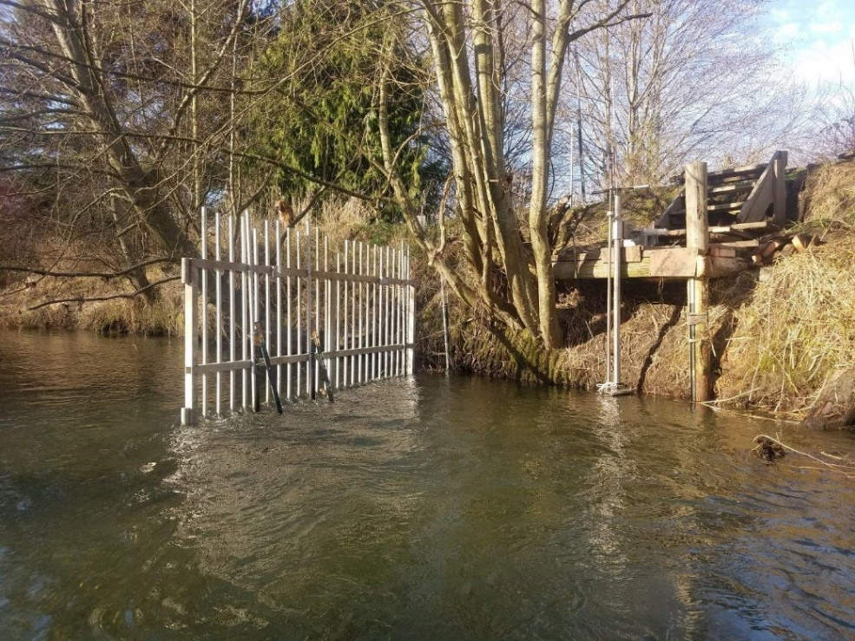

**Figure 3** SONAR unit deployment via a pole mount and platform in the Dungeness River in 2020. Picket weir is the upstream picket weir.

We deployed the ARIS 1800 Explorer, manufactured by Sound Metrics, of Bellevue, Washington. The ARIS 1800 uses 96 beams at 1.1/1.8 megahertz (Mhz) to project a 28-degree acoustic wedge. The SONAR unit was adjusted to have a pitch of 3.5 degrees to -8 degrees to ensonify the entire water column and channel. The unit was checked daily and adjusted as necessary to maintain full ensonification of the channel. Imagery was continuously recorded 24 hours a day, and saved in 30-minute files, so that 48 individual files were recorded for each full day of operation.

The SONAR was operated from early February or early March through late June, mid-July, or early October (Table 1, Figure 4). Other than a 22-day suspension in 2020 due to COVID-19 protocols, there were few outages and gaps in data collection (Table 2, Figure 4). SONAR imagery was reviewed for steelhead passage from the first day of operation through May 30th in each year.

**Table 1. SONAR operations on the Dungeness River, 2018-2022.**

|  |  |  |  |  |
| --- | --- | --- | --- | --- |
|  | SONAR Operation | | Steelhead Period | |
| Year | First day | Last day | First day | Last day |
| 2018 | Feb. 28 | Jul. 17 | Feb. 28 | May 30 |
| 2019 | Mar. 5 | Oct. 10 | Mar. 5 | May 30 |
| 2020 | Feb. 14 | Jul. 25 | Feb. 14 | May 30 |
| 2021 | Feb. 2 | Jun. 22 | Feb. 2 | May 30 |
| 2022 | Feb. 9 | Jun. 25 | Feb. 9 | May 30 |

**Figure 4- Kevin’s figure of yellow and purple sonar operations by day and by hour. Suggest adding a red line/block around the period that we are calling the “steelhead season.”**

**Figure 4** SONAR operations by day and hour, 2018-2022. Yellow indicates periods the SONAR operated, and purple indicates periods the SONAR was not operating. The red rectangles show the period of steelhead migration.

**Table 2. Kevin’s table of missing data at hour, 6-hr period, day for each year**

## Species composition sampling

Species composition sampling was conducted weekly, as river conditions allowed, during the period of SONAR operations in 2021 and 2022. A fine monofilament gill net 36 feet wide by 8 feet deep with a 2-inch mesh (4-inch stretch) was drifted through all sampleable habitat in the lower river from RM 3.3 to RM 0.5 (2021) or RM 0.8 (2022). Encountered fish were removed immediately from the net, sedated in a solution of tricaine mesylate (MS-222), and sampled for species, origin, length, gender, scales, and DNA. Captured steelhead were assessed for kelt status.

No regular species composition sampling was conducted in 2018, 2019, or 2020. In 2019, three sampling efforts targeting bull trout were conducted once per week in June at sites throughout the Dungeness and Gray Wolf rivers.

## Data processing

In 2018 all 30-minute files (2 per hour, 48 per day) were processed and reviewed for fish migration. We were unable to complete review of the imagery during the 2018 SONAR season, and in 2019 we initiated a subsampling scheme to enable the project team to complete review of the entire period of steelhead passage. In 2019- 2022 the first 30 minutes of each hour were processed and reviewed for fish migration. A subset of days was fully reviewed (60 minutes of each hour) to compare fish migration with subsampled data (first 30 minutes of each hour). Another subset of days was double, or triple, reviewed to compare fish counts and lengths among each year’s 2 or 3 data reviewers.

Each reviewed imagery file was processed using Sound Metric’s proprietary software ARISFish (v2.6.3 – v2.8.0). First, raw image files were background subtracted, which removed static objects from the image so that only objects in motion are shown. Then, an echogram was created, which transformed the image into a graph of distance (y-axis) and time (x-axis), so that objects in motion appeared as white “tracks.” The echogram enabled the data reviewer to quickly navigate to parts of the image file that contained objects that could be migrating fish. These tracks were then manually viewed alongside the raw image file to determine if the object was a fish to be further investigated.

Fish greater or equal to 45 centimeters (cm) were measured, marked, and counted using the ARISFish software. Forty-five cm was determined to be the minimum length of a potential steelhead, based on captures of steelhead during sampling in the Dungeness River 2014, 2015, and 2017 by the Jamestown S’Klallam Tribe (JSK) (unpublished data, C. Burns). Only fish that completely moved through the SONAR beams were counted; fish that nosed in and out or did not completely move from one side of the beams to the other were not counted. For each fish counted the following data were recorded:

* Date
* Hour of the 30-minute image file (e.g., 14:00, 14:30)
* Time
* Frame
* Direction of travel (upstream or downstream)
* Range (distance from the SONAR)
* Length of the fish in cm
* Data reviewer confidence (1 = extremely confident that the object counted is a fish ≥ 45 cm, 2 = somewhat confident that the object is a fish ≥ 45 cm, 3 = object of interest)

If no fish were observed in the 30-minute image file, a line of data with “NO FISH” was recorded to indicate that the file was reviewed for fish, but no fish ≥ 45 cm were present. Marked fish were automatically saved within the image file for later error checking; data were also recorded within an Excel spreadsheet for data summarization and analysis.

## Abundance estimation

SONAR fish targets that were ≥ 45 cm, moved completely through the SONAR beams (direction of travel = upstream or downstream), and had a data reviewer confidence = 1 were included in the final fish counts and abundance estimate.

### Extrapolating subsampled data

### Apportioning fish counts to species

### Accounting for missing data

Partial data

Outages

### Adjusting for kelts

### Accounting for data reviewer bias

# Results

## Fish migration

Steelhead sized fish were present immediately upon deployment of the SONAR in all years. Net fish movement was upstream over the course of the steelhead migration period, and daily net upstream counts peaked in XX in most years (Figure 5). Beginning in late April, net upstream movements decreased, and net downstream movements became more common, suggesting steelhead were kelting.

**Figure 5** Net upstream passage of fish……

## Species composition sampling

Fourteen species composition sampling events were conducted between early February and late June in both 2021 and 2022. Steelhead and bull trout were encountered during sampling. The majority of captured steelhead were natural-origin; three hatchery-origin steelhead were captured in early April 2021, and four hatchery-origin steelhead were captured in 2022- three in mid- March and one in late May. Steelhead kelts were encountered starting in May 2022, and in early June 2021.

**Table 3** Counts of species encountered during species composition sampling in the lower Dungeness River in 2021 and 2022.

|  |  |  |  |
| --- | --- | --- | --- |
| Year | Date | Bull trout | Steelhead |
| 2021 | Feb. 3 | 3 | 0 |
| Feb. 17 | 1 | 2 |
| Feb. 25 | 0 | 2 |
| Mar. 1 | 0 | 0 |
| Mar. 17 | 0 | 1 |
| Mar. 25 | 0 | 2 |
| Apr. 1 | 0 | 2a |
| Apr. 8 | 0 | 6 a |
| Apr. 14 | 0 | 4 |
| Apr. 28 | 2 | 1 |
| May 6 | 0 | 0 |
| May 12 | 0 | 0 |
| Jun. 8 | 7 | 1 c |
| Jun. 17 | 5 | 0 |
| Total | 18 | 21 |
|  | | | |
| 2022 | Feb. 2 | 2 | 0 |
| Feb. 9 | 0 | 0 |
| Feb. 15 | 1 | 0 |
| Feb. 22 | 0 | 2 |
| Mar. 9 | 1 | 2b |
| Mar. 16 | 1 | 4 b |
| Mar. 23 | 1 | 2 |
| Mar. 30 | 0 | 2 |
| Apr. 7 | 1 | 3 |
| Apr. 19 | 3 | 7 |
| May 4 | 2 | 6c |
| May 20 | 2 | 3 b |
| Jun. 1 | 2 | 1 |
| Jun. 22 | 1 | 0 |
| Total | 17 | 32 |

a 1 hatchery-origin steelhead was captured on April 1, 2021, and 2 hatchery-origin steelhead were captured on April 8, 2021.

b 1 hatchery-origin steelhead was captured on March 9, 2022; 2 hatchery-origin steelhead were captured on March 16, 2022, and 1 hatchery-origin steelhead was captured on May 20, 2022.

c  One steelhead was identified as a kelt on June 8, 2021.

d Four steelhead were identified as kelts on May 4, 2022, 2 steelhead were identified as kelts of May 20, 2022, and 1 was identified as a kelt on June 1, 2022.

Encountered steelhead averaged 644 millimeters (mm) fork length (FL) in both 2021 and 2022 and ranged from 400 mm to 780 mm FL in 2021, and from 550 to 800 mm FL in 2022. Captured bull trout were smaller on average than steelhead and averaged 478 mm FL in 2021 and averaged 565 mm FL in 2022. Bull trout ranged from 270 mm to 660 mm FL in 2021, and from 395 mm to 700 mm FL in 2022.

**Figure 6** Length distributions of steelhead, bull trout, and rainbow trout encountered during species composition sampling in the lower Dungeness River in 2021 and 2022. Kevin’s histogram

## Abundance estimate

## Data reviewer comparisons

Five days of data were triple reviewed by the two primary data reviewers and a third data reviewer to compare counts and measurements among the reviewers. The two primary data reviewers marked 88% of the same fish (Table 4). Reviewer 1 consistently measured fish as larger than Reviewer 2 (93% of the time), by an average of 6.4 cm. Twenty-three percent of fish lengths were highly variable between the two primary reviewers, mainly on days with poor image quality. Fish counts and lengths were more variable between all three reviewers (Table 5). Upstream migrating fish counts were more consistent than downstream counts for all three reviewers.

# Discussion

* Species composition sampling- is it capturing fish that are moving past the sonar site or also fish that are holding? Some bull trout recaptured 2 of 3 times in same spot, and in both years

# Recommendations

* Deploy the SONAR in early to mid-January to capture start of steelhead return
* Consider using Echoview software to develop automated data processing flow and reduce data review time
* Investigate potential collaborations with external partners to leverage machine learning/AI to automate data processing and reduce data review time

# Acknowledgements

Andrew Simmons, Dan Gorze, Jayson Gallatin, Brent Trim, and Greg Boecker of WDFW operated, maintained, and reviewed SONAR imagery data. Calvin Stokes also reviewed SONAR imagery. Peter Topping provided project support and advice. Kathryn Sutton led weekly species composition sampling with the help of many volunteers including Calvin Stokes, Jenni Whitney, Scott Williams, Jeff Gufler, David Thomas, Jacob Portney, Caleb Owen, and Kayla Own of WDFW, Chris Burns, Jarrett Burns, Casey Allen, and Aaron Brooks of the Jamestown S’Klallam Tribe, Dave Shreffler of Shreffler and Associates, Keith Denton of Keith Denton and Associates, and Roger Peters, Roger Tabor, Greg Byford, Evan Lewis, Jakob Bengelink, and Jack Brill of the U.S. Fish and Wildlife Service.